Management of acute pain after surgery
Pain after cardiac surgery is normal, but it is not normal to suffer through it.
Why relieve pain?
1. To maximize your physical comfort. This will allow you to accomplish your daily activities such as:
- To get from your bed to the chair
- To walk in the hall
- To take a shower
- Etc…

2. To decrease pulmonary problems such as pneumonia
Pain assessment method use is a numerical scale from 0 to 10
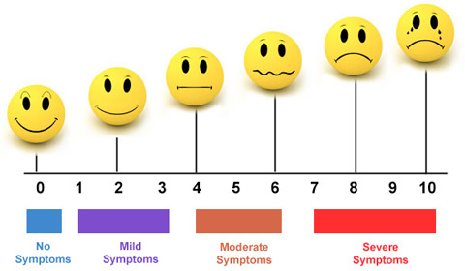
Severe pain
Moderate pain
Light pain
No pain

The role of the nurse | The role of the patient
• To regularly assess pain  • To evaluate the effectiveness of treatments  • To support the patient in optimizing his or her pain control | • To inform the nurse of the presence of pain and or discomfort  • To tell the nurse if the pain or discomfort persists  • To tell the nurse if you have side effects such as nausea, vomiting, constipation, etc…

For more information please consult: https://www.icm-mhi.org/fr/soins-et-services/services-et-cliniques/service-danalgesie-postoperatoire

